1.Display students with marks between 70 and 90.

QUERY : select name from students10 where marks between 70 and 90;

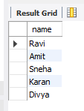

2.List students aged between 20 and 22.

QUERY : select name ,age from students10 where age between 20 and 22;

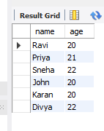

3.Find students whose name starts with 'P'.

QUERY : select name from students10 where name like 'p%';

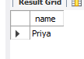

4.Find students whose city contains 'ai'.

QUERY : select name from students10 where city like '%ai%';

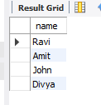

5.Find names where the second character is 'r'.

QUERY : select * from students10 where name like '_r%';

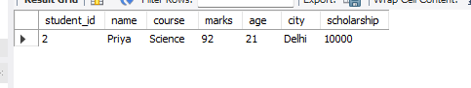

6.Show top 3 students with highest marks.

QUERY : select * from students10 order by marks desc limit 3;

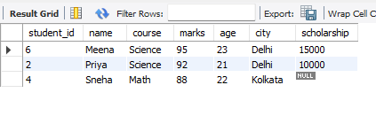

7.Show students who have a scholarship.

QUERY : select * from students10 where scholarship is not null ;

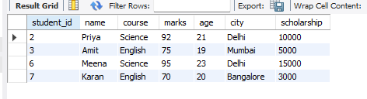

9.Show students in 'Math' course AND age > 21.

QUERY : SELECT * FROM students10 WHERE course = 'Math' and age>21;

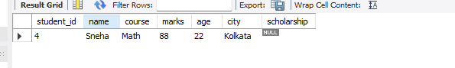

10.Show students in 'Science' OR 'English' course.

QUERY : SELECT name FROM students10 WHERE course IN ('Science','English');

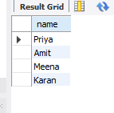

11.Show students NOT from 'Mumbai'.

QUERY : SELECT name FROM students10 WHERE city != 'Mumbai';

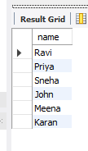

13.Replace NULL scholarship with 0 using IFNULL.

QUERY : select name,ifnull(scholarship, 0) as scholarship from students10 ;

